CS 499 Milestone Two: Enhancement One – Software Design and Engineering
My Christmas List App, which was initially developed as a web application project to assist users in organizing and managing gift ideas online, is the artifact I chose for this academic course. Firebase Firestore, HTML, CSS, and JavaScript were used in the development of the application. Users can examine gift goods, mark products as purchased or unpurchased in real time, and log in using Google login. I chose this artifact because it exemplifies several software engineering aspects, such as database integration, front-end development, authentication, and user interface design. The concept also fits in nicely with my professional interests in contemporary online apps and software development.
I concentrated on enhancing the application's general software architecture as well as its functionality for this improvement. The addition of a search bar function that enables users to swiftly look through gift products within the program is one of the main anticipated improvements. I also started organizing other enhancements, such sorting and classifying gifts, making the user interface more responsive for mobile devices, rearranging the JavaScript code into more reusable functions, and enhancing the application's error handling. The software's usability, scalability, and maintainability are all improved by these improvements, which also make the user experience more polished.
This improvement exemplifies a number of critical software engineering competencies and learning objectives. First, the project shows how to use web development tools and contemporary programming techniques to construct and assess computing solutions. My ability to work with real-time databases and dynamic user interactions is demonstrated by the integration of Firebase Firestore with JavaScript. Additionally, software engineering concepts like maintainability, modularity, and usability are demonstrated by rearranging the application structure and enhancing the product's usefulness. The project also shows my proficiency with industry-relevant tools and technologies, such as Firebase, GitHub, GitHub Pages, and JavaScript programming techniques.
I discovered the value of effectively arranging code and creating apps with future scalability in mind throughout the enhancement phase. Along with strengthening the application's overall structure, I also gained more experience solving Firebase integration and JavaScript difficulties. Maintaining clear and legible code while making useful enhancements was one of the challenges I encountered. Making sure Firebase functionality upgrades continued to perform properly while developing new features like search and filtering capabilities presented another difficulty. Despite these difficulties, the process of improvement strengthened my comprehension of software design and development methodologies.
All things considered, this artifact shows how much my software engineering abilities have improved throughout the course of the Computer Science curriculum. The Christmas List App has been improved in terms of professionalism and functionality, and it is now ready to be included in my final ePortfolio.
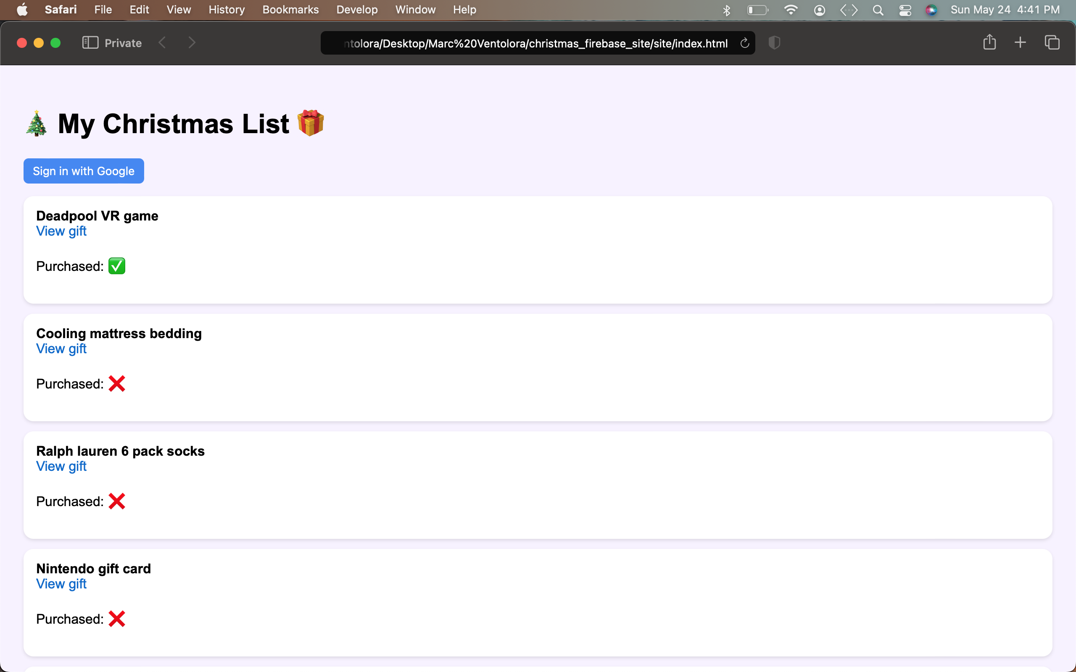
Before Enhancement:

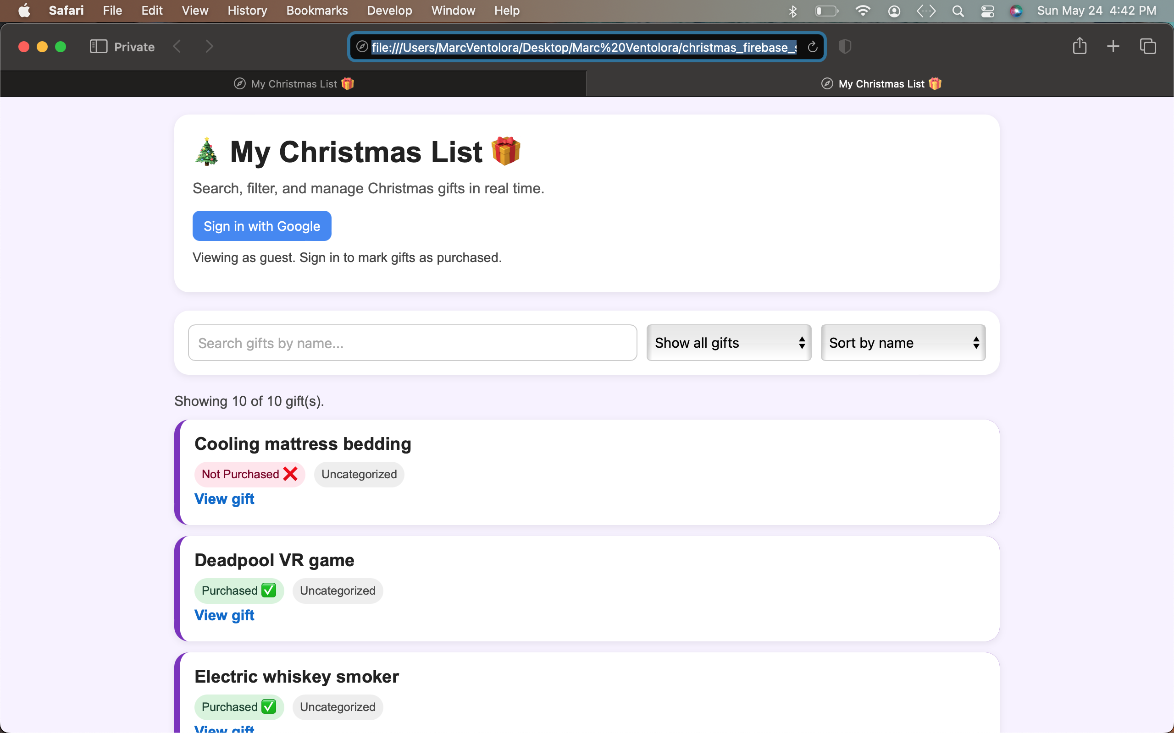
After Enhancement:
By adding search, filtering, sorting, and better interface design, the enhancement process aimed to improve usability, scalability, and user engagement.

